"""

Created on Sun Jun 17 08:14:33 2018

@author: sumedh

"""

import os

import pandas as pd

import numpy as np

## Split data in Training (Development Sample) 70% and Hold-out Sample 30%

# Set working directory

os.chdir("D:/Great Lakes PGPDSE/Great Lakes/10 Supervised Learning - Classification/Supervised Learning Classification/Mini_Project")

#Loading Dataset

pl = pd.read_csv("PL_XSELL.csv")

pl['split'] = np.random.randn(pl.shape[0], 1)

br = np.random.rand(len(pl)) <= 0.7

train = pl[br]

test = pl[~br]

# Writing Development_Sample and Hold_Out_Sample into two different csv files

train.to_csv("Development_Sample.csv", encoding='utf-8', index=False)

test.to_csv("Hold_out_Sample .csv", encoding='utf-8', index=False)

## Classification Tree on Unbalanced Dataset

import os

import pandas as pd

#Set the working directory

os.chdir("D:/Great Lakes PGPDSE/Great Lakes/10 Supervised Learning - Classification/Supervised Learning Classification/Mini_Project")

#Load the Dataset

CTDF_dev = pd.read_csv("Development_Sample.csv")

CTDF_holdout = pd.read_csv("Hold_out_Sample .csv")

del CTDF_dev['split']

del CTDF_holdout['split']

print( len(CTDF_dev), len(CTDF_holdout)) ###13993 6007

CTDF_dev.head()

import numpy as np

import matplotlib.pyplot as plt

#Data Preprocessing

#Splitting into features and response variables

CTDF_dev.columns

X = CTDF_dev[['GENDER', 'BALANCE', 'OCCUPATION',

'AGE_BKT', 'SCR', 'HOLDING_PERIOD', 'ACC_TYPE',

'LEN_OF_RLTN_IN_MNTH', 'NO_OF_L_CR_TXNS', 'NO_OF_L_DR_TXNS',

'TOT_NO_OF_L_TXNS','FLG_HAS_CC','AMT_L_DR', 'FLG_HAS_ANY_CHGS',

'AMT_MIN_BAL_NMC_CHGS','FLG_HAS_OLD_LOAN']]

#Categorical Variable to Numerical Variables

X_train = pd.get_dummies(X)

X_train.columns

y_train = CTDF_dev["TARGET"]

print (type(X_train) , type(y_train))

#Decision Tree

#Loading the library

from sklearn.tree import DecisionTreeClassifier

#Setting the parameter

clf = DecisionTreeClassifier(criterion = "gini" ,

min_samples_split = 100,

min_samples_leaf = 10,

max_depth = 100)

#Calling the fit function to built the tree

clf.fit(X_train,y_train)

import pydot

from sklearn.tree import tree

from sklearn.tree import export_graphviz

from sklearn.externals.six import StringIO

dot_data = StringIO()

feature_list = list(X_train.columns.values)

export_graphviz(clf,

out_file = dot_data,

feature_names = feature_list)

graph=pydot.graph_from_dot_data(dot_data.getvalue())

graph[0].write_pdf("D:/Great Lakes PGPDSE/Great Lakes/10 Supervised Learning - Classification/Supervised Learning Classification/Mini_Project.classification_tree_output.pdf")

Nodes = pd.DataFrame(clf.tree_.__getstate__()["nodes"])

Nodes

feature_importance = pd.DataFrame([X_train.columns,

clf.tree_.compute_feature_importances()])

feature_importance.T

## Let us see how good is the model

pred_y_train = clf.predict(X_train )

pred_y_train

## Let us see the classification accuracy of our model

from sklearn.metrics import accuracy_score

from sklearn.metrics import roc_curve

from sklearn.metrics import auc

score = accuracy_score(y_train, pred_y_train)

score ##0.8891588651468592

y_train_prob = clf.predict_proba(X_train)

## AUC for training

fpr, tpr, thresholds = roc_curve(y_train, y_train_prob[:,1])

auc(fpr, tpr) ## 0.8909147836850357

## Let us see how good is the model

X_holdout = CTDF_holdout[['GENDER', 'BALANCE', 'OCCUPATION',

'AGE_BKT', 'SCR', 'HOLDING_PERIOD', 'ACC_TYPE',

'LEN_OF_RLTN_IN_MNTH', 'NO_OF_L_CR_TXNS', 'NO_OF_L_DR_TXNS',

'TOT_NO_OF_L_TXNS','FLG_HAS_CC','AMT_L_DR', 'FLG_HAS_ANY_CHGS',

'AMT_MIN_BAL_NMC_CHGS','FLG_HAS_OLD_LOAN']]

X_test = pd.get_dummies(X_holdout)

y_test = CTDF_holdout["TARGET"]

pred_y_test = clf.predict(X_test)

score_h = accuracy_score(y_test, pred_y_test)

score_h ## 0.874812718495089

y_test_prob = clf.predict_proba(X_test)

fpr, tpr, thresholds = roc_curve(y_test, y_test_prob[:,1])

auc(fpr, tpr) ## 0.7990326076444083

# AUC_diff = (0.8909147836850357-0.7990326076444083)/0.8909147836850357

# AUC_diff = 0.1031323957388841

y_freq = np.bincount(y_train)

y_val = np.nonzero(y_freq)[0]

np.vstack((y_val,y_freq[y_val])).T

#array([[ 0, 12251],

# [ 1, 1742]], dtype=int64) 1742/(12251+1742)=12.44

#Cross validation function

from sklearn.cross_validation import cross_val_score

scores = cross_val_score(clf, X_train , y_train, cv = 10, scoring='roc_auc')

scores.mean() # 0.7879884317540934

scores.std() # 0.0147261362940826

y_train_prob = clf.predict_proba(X_train)

fpr, tpr, thresholds = roc_curve(y_train, y_train_prob[:,1])

auc(fpr, tpr) # 0.8909147836850357

y_test_prob = clf.predict_proba(X_test)

fpr, tpr, thresholds = roc_curve(y_test, y_test_prob[:,1])

auc(fpr, tpr) # 0.7990326076444083

## Tuning the Classifier using GridSearchCV

from sklearn.grid_search import GridSearchCV

#help(GridSearchCV)

param_dist = {"criterion": ["gini","entropy"],

"max_depth": np.arange(3,10),

}

tree = DecisionTreeClassifier(min_samples_split = 100,

min_samples_leaf = 10)

tree_cv = GridSearchCV(tree, param_dist, cv = 10,

scoring = 'roc_auc', verbose = 100)

tree_cv.fit(X_train,y_train)

## Building the model using best combination of parameters

print("Tuned Decision Tree parameter : {}".format(tree_cv.best_params_))

# Tuned Decision Tree parameter : {'criterion': 'entropy', 'max_depth': 9}

classifier = tree_cv.best_estimator_

classifier.fit(X_train,y_train)

#predicting probabilities

y_train_prob = classifier.predict_proba(X_train)

fpr, tpr, thresholds = roc_curve(y_train, y_train_prob[:,1])

auc_prob_d = auc(fpr, tpr)

auc_prob_d # 0.8208470013132318

y_test_prob = classifier.predict_proba(X_test)

fpr, tpr, thresholds = roc_curve(y_test, y_test_prob[:,1])

auc_prob_h = auc(fpr, tpr)

auc_prob_h # 0.7508230646573208

#(auc_prob_d-auc_prob_h)/auc_prob_d # 0.0853069287502826

## Rank Ordering

Prediction = classifier.predict_proba(X_train)

CTDF_dev["prob_score"] = Prediction[:,1]

#scoring step

#decile code

def deciles(x):

decile = pd.Series(index=[0,1,2,3,4,5,6,7,8,9])

for i in np.arange(0.1,1.1,0.1):

decile[int(i*10)]=x.quantile(i)

def z(x):

if x<decile[1]: return(1)

elif x<decile[2]: return(2)

elif x<decile[3]: return(3)

elif x<decile[4]: return(4)

elif x<decile[5]: return(5)

elif x<decile[6]: return(6)

elif x<decile[7]: return(7)

elif x<decile[8]: return(8)

elif x<decile[9]: return(9)

elif x<=decile[10]: return(10)

else:return(np.NaN)

s=x.map(z)

return(s)

def Rank_Ordering(X,y,Target):

X['decile']=deciles(X[y])

Rank=X.groupby('decile').apply(lambda x: pd.Series([

np.min(x[y]),

np.max(x[y]),

np.mean(x[y]),

np.size(x[y]),

np.sum(x[Target]),

np.size(x[Target][x[Target]==0]),

],

index=(["min_resp","max_resp","avg_resp",

"cnt","cnt_resp","cnt_non_resp"])

)).reset_index()

Rank = Rank.sort_values(by='decile',ascending=False)

Rank["rrate"] = Rank["cnt_resp"]*100/Rank["cnt"]

Rank["cum_resp"] = np.cumsum(Rank["cnt_resp"])

Rank["cum_non_resp"] = np.cumsum(Rank["cnt_non_resp"])

Rank["cum_resp_pct"] = Rank["cum_resp"]/np.sum(Rank["cnt_resp"])

Rank["cum_non_resp_pct"]=Rank["cum_non_resp"]/np.sum(Rank["cnt_non_resp"])

Rank["KS"] = Rank["cum_resp_pct"] - Rank["cum_non_resp_pct"]

Rank

return(Rank)

Rank = Rank_Ordering(CTDF_dev,"prob_score","TARGET")

Rank # Considere the highest KS value among all available values 0.461771

## Let us see the Rank Ordering on Hold-Out Dataset

Prediction_h = classifier.predict_proba(X_test)

CTDF_holdout["prob_score"] = Prediction_h[:,1]

Rank_h = Rank_Ordering(CTDF_holdout,"prob_score","TARGET")

Rank_h # On Holding dataset highest KS value to be considered i.e.0.362128

#Rank = (Rank - Rank_h) / Rank

# (0.461771-0.362128)/0.461771 = 0.21578444726931745

y_freq = np.bincount(y_test)

y_val = np.nonzero(y_freq)[0]

np.vstack((y_val,y_freq[y_val])).T

# array([[ 0, 5237],

# [ 1, 770]], dtype=int64) 770/(770+5237) = 12.8183

CTDF_dev ( training dataset ) with probability score and decile

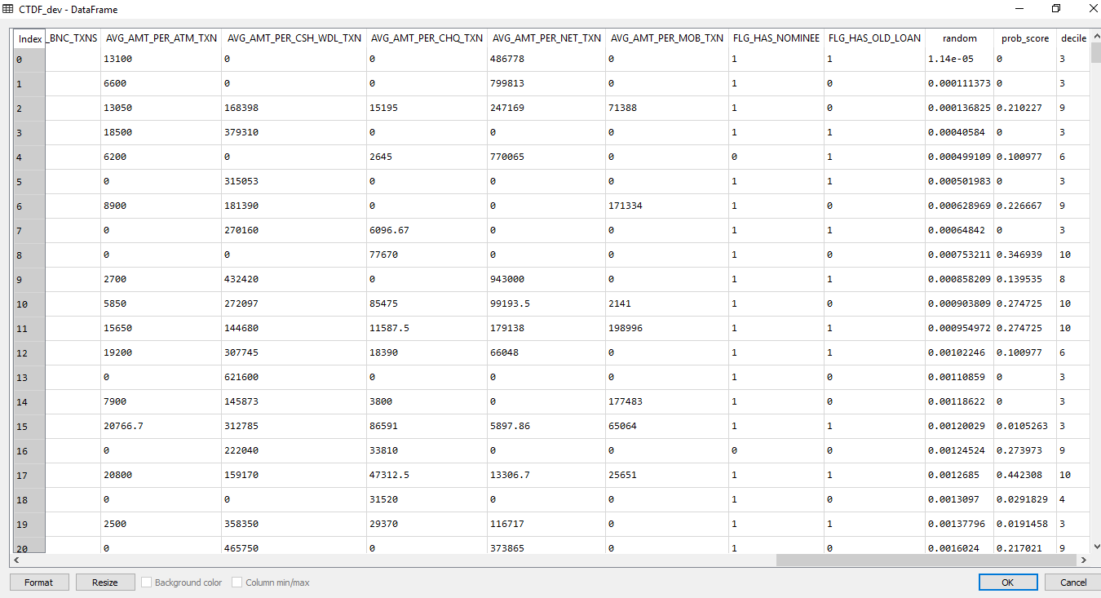

CTDF_holdout ( testing dataset ) with probability score and deciles in it.

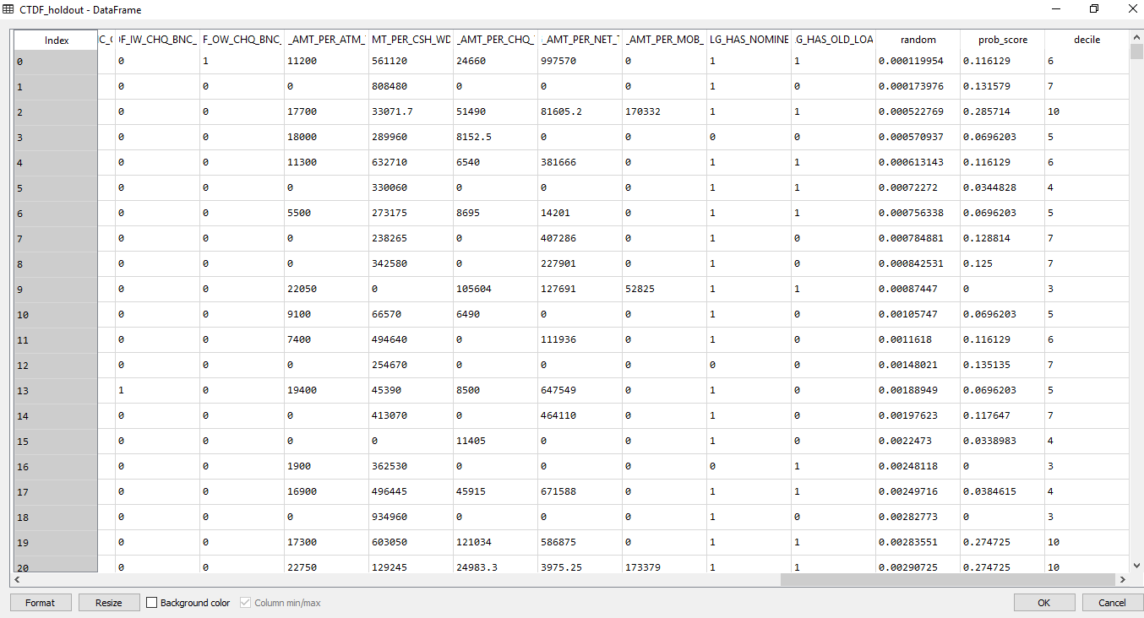

Rank ordering of the dataset ( train dataset ) – Development

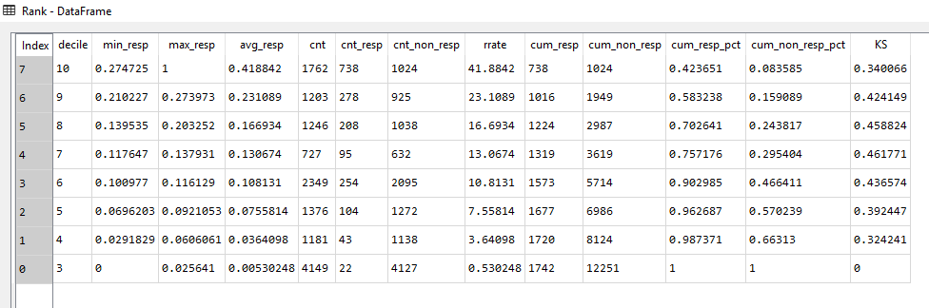

For Training dataset maximum ks statistics value is coming at 7th decile and its value is 0.461771.

=((0.34*738)+(0.42*278)+(0.4588*208)+(0.4617*95))/(738+278+208+95) =0.3828.

If we target top four decile i.e. 10,9,8 and 7 having the maximum KS Statistics is 0.461771. Then there is a chance of 0.3828 times We can can taget the customer for Personal Loan having the higher probability of taking the Personal loan by them.

Rank ordering of the dataset ( test dataset ) – Hold out

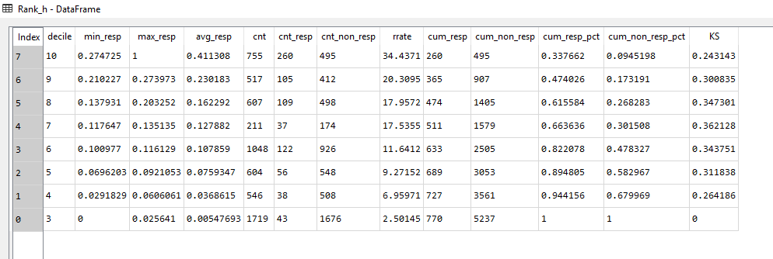

For Testing dataset maximum ks statistics value is coming at 7th decile and its value is 0.362128.

=((0.2431*260)+(0.30*105)+(0.34*109)+(0.36*37)/(260+105+109+37)=0.2839

If we target top four decile i.e. 10,9,8 and 7 having the maximum KS Statistics is 0.62128. Then there is a chance of 0.2839 times We can can taget the customer for Personal Loan having the higher probability of taking the Personal loan by them.

Accuracy for the X_train model is 88.91%

AUC curve for the X_train model is 89.09%.

Accuracy for the y_test data is 87.48%

AUC curve for the y_test data is 79.09%.

This Model is showing better results in Python in compare to R.

AUC and Accuracy of model is coming less for same dataset in R but for same dataset in Python showing high results for same parameters.